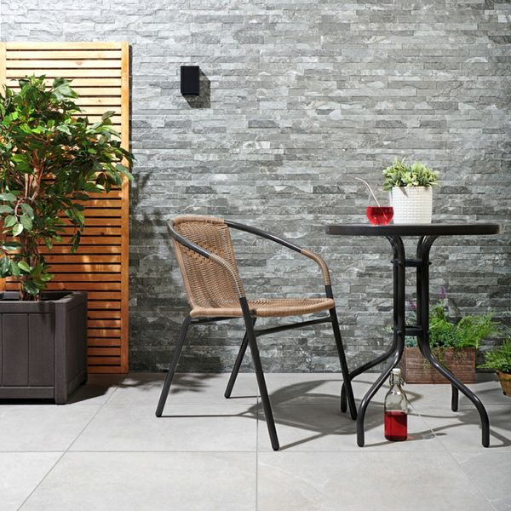**Vesuvius Charcoal Split Face Effect Tiles:**

## **Product Description**

Create a contemporary wall display in your home with these Charcoal Tiles. Part of our [**Vesuvius Split Face Effect Tiles**](https://www.wallsandfloors.co.uk/wall-tiles/vesuvius-split-face-effect-tiles) range, it has a multi-levelled slate-effect surface. Unlike our natural slate Splitface Mosaic Tiles, it's suitable for external applications; as well as shower areas and wet rooms.

**What's special about these tiles?**

> Realistic slate effect design  
> Characterful textured surface  
> Perfect for use inside and outside the home

## **Product Info**

* Product ID: 12321
* Tiles Per SQM: 5.5555555555556
* Sale by: Per SQM
* Size: 600x300x10mm
* Weight: 3.67 KG
* Material Type: Porcelain
* Finish: Matt
* Colour: Grey
* Suitability: Walls
* Area Of Usage: External
* Grade: 4
* Rectified Edge: No
* Underfloor Heating: No
* Thickness (mm): 10